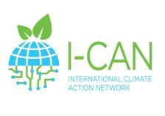
I-CAN IO1 Climate Action Guide 2021


Your reflections

What has changed and what has stayed constant in learning?

MOST SIGNIFICANT CHANGES | MOST CONSTANT ELEMENTS

