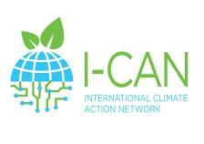
I-CAN IO1 Climate Action Guide 2021


Your reflections

Now write a short description on how you see your own identity as a teacher:

